**Travel Planner Assist**

**Abstract:**

Developing a chatbot that assist travelers in planning their trips. It can recommend top hotels and suggest itineraries based on user-specified destinations.

**Objectives:**

**Build a chatbot that can do the following –**

1. User Input travel destination.
2. User Input from Travel date.
3. User input to select any preferred activities they are planning to do.
4. User input to select how many people will be travelling.
5. User Input to select Meal Preferences and budget level**.**

**Design:**

**System Design**

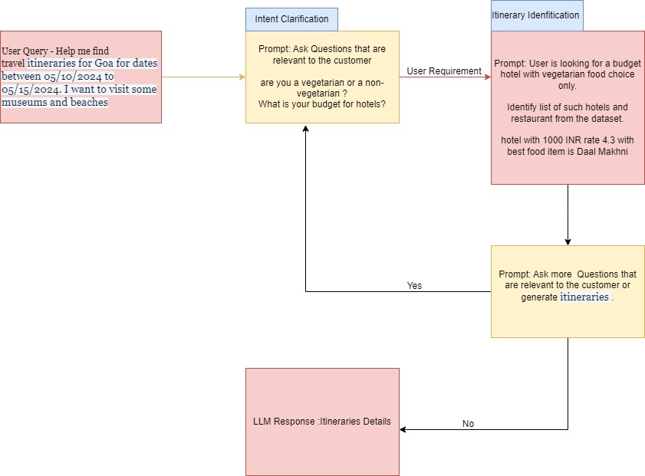

**Implementation:**

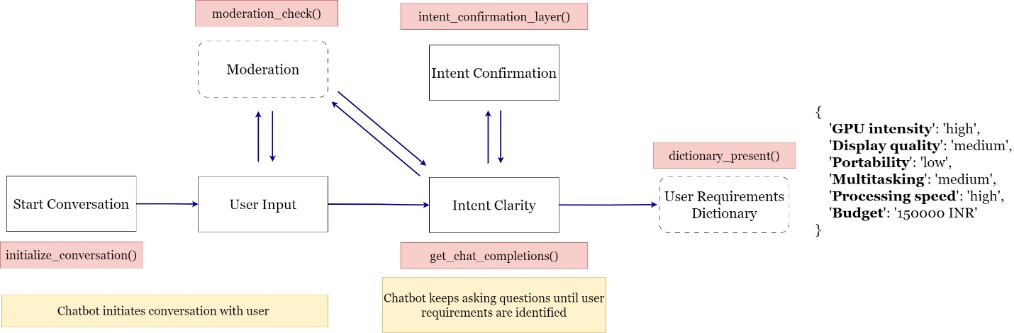

**Challenges:**

**Lesson Learned:**